Exercise 2:

1. docker pull alpine

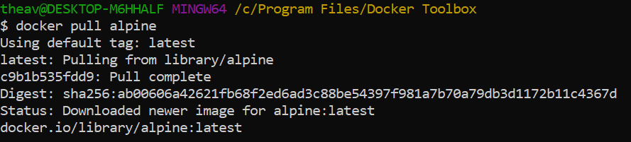

1. docker images

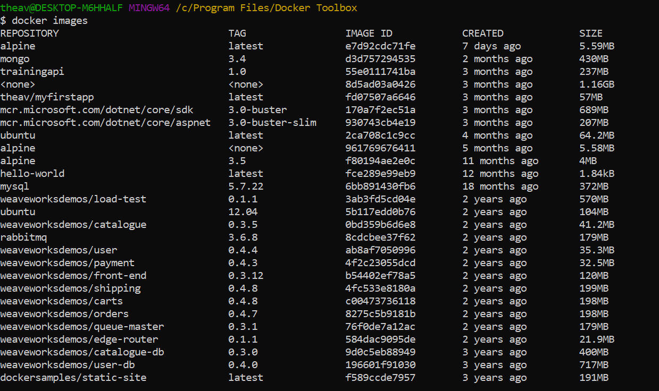

1. docker run alpine ls -l

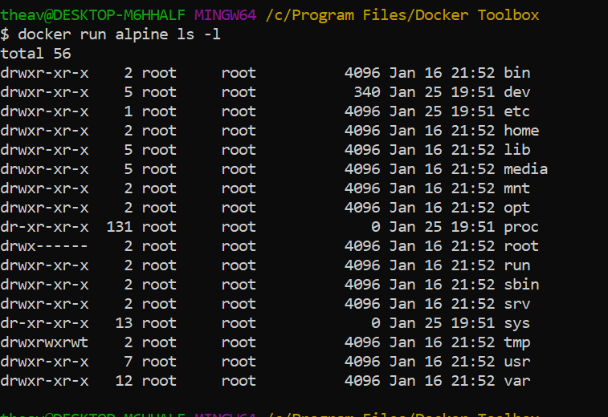

1. docker run alpine echo “hello from alpine”

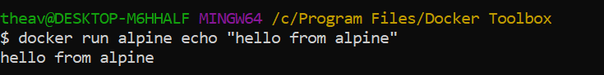

1. docker run alpine /bin/sh

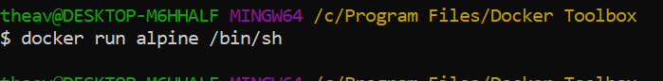

1. docker run alpine ls -l /bin/sh

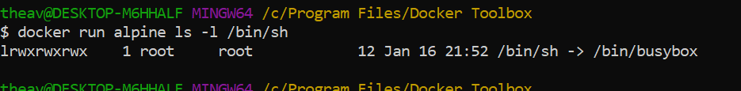

1. docker ps



1. docker ps -a

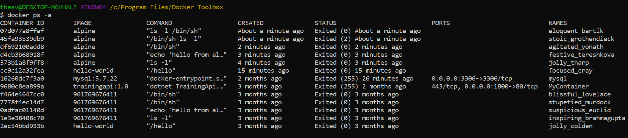

1. docker run -it alpine /bin/sh

